STEPS TO SET SECURITY GROUP FOR AN INSTANCE:

1.Open the Amazon EC2 console

2.From the navigation bar, select a region for the security group. Security groups are specific to a region, so we should select the same region in which we created our key pair.

3.Click Security Groups in the navigation pane.

4.Click Create Security Group.

5.Enter a name for the new security group and a description.

6.From the VPC list, select our VPC. If we have a default VPC, it's the one that is marked with an asterisk (\*)

7.On the Inbound tab, create the following rules and then click Create

8.Select HTTP from the Type list, and make sure that Source is set to Anywhere (0.0.0.0/0).

9.Select HTTPS from the Type list, and make sure that Source is set to Anywhere (0.0.0.0/0).

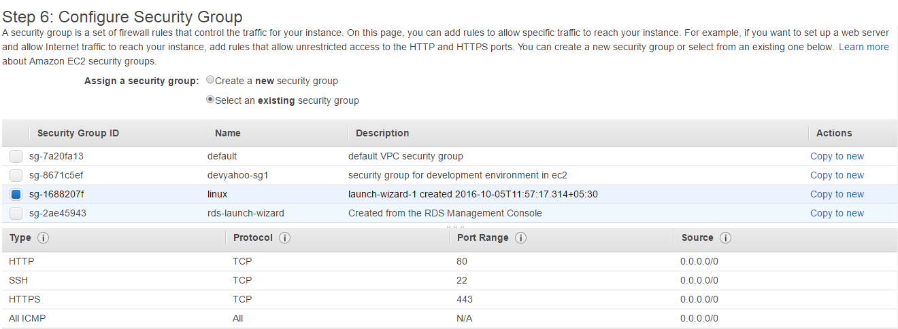

10.Select SSH from the Type list if we need Linux AMI. In the Source box, ensure Custom is selected, and specify the public IP address of our computer or network in CIDR notation.